**Report on the activities**

**of the Foundation Maria Theresia Scherer Ingenbohl**

**Year 2016**

The Foundation Maria Theresia Scherer Ingenbohl was established on March 7th, 2013. Its Headquarters are in Ingenbohl. In accordance with the way of life of the Sisters of Mercy of the Holy Cross, Ingenbohl-Brunnen, it aims at promoting, supporting and granting non-profit humanitarian aid, including emergency relief in ecclesial and secular tasks, nationally and internationally. The Foundation may grant such aid also to third parties, as well as to the Institute of the Sisters of Mercy of the Holy Cross.

Relief of all sorts of human need was and remains the special task of the Institute of the Sisters of Mercy of the Holy Cross. This requires us to be open for the needs of the time. Fr. Theodosius Florentini, our Founder, said: „I shall not rest as long as there is a poor child in the world. “

The highest authority of the Foundation is the Foundation Council. It is made up of eight members who operate on an honorary basis. In 2016, the Foundation Council met for two sessions. The Foundation Council discussed applications which were granted amounts of more than sfrs. 5‘000.-.

The Executive Board is nominated by the Foundation Council; it consists of four members and carries out current transactions. In 2016, the Executive Board, in seven sessions, based on its statutes, granted amounts for support of up to 5000.- sfrs. All the applications were previously examined through personal or written contacts with the applicants. The members of the Executive Board are assigned definite areas (provinces, vicariates, countries) to deal with. Applications beyond the competence of the Executive Board, were presented to the Foundation Council.

The most important tasks of the Executive Board are the screening and dealing with applications, as well as the statements of accounts from the part of the applicants. These, moreover, stand in personal or written contact with the donors. The graph shows the survey on the allocation of the donations in the year 2016.

In the year 2016, 70 applications were dealt with, out of which 68 were granted. The graph next to this shows a survey.

**As examples of helps with sustainability, we now mention nine applications of the year 2016:**

1. ***Holy Cross Sisters Society in Kurseong, Darjeeling*: Schooling for poor children of the tea-gardens in the school of the Holy Cross Sisters in Bokola, Assam**

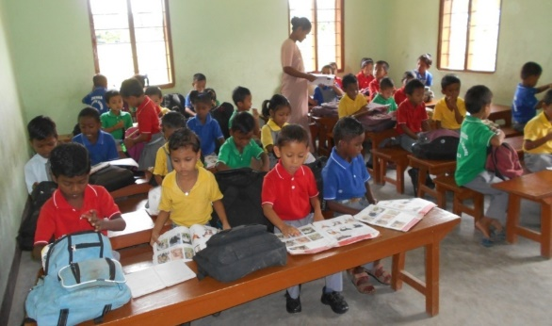

The Holy Cross Sisters work towards the basic education and empowering of underprivileged persons working in the teagardens and in other places of the North-Eastern Federal States of India.

In the Federal State of Assam, there are three establishments, one of which is Bokola. There, the sisters go to the families, instruct adults, make it possible for the children to go to school and motivate them to learn and be educated.

People in Bokola are very poor. Most of them depend on the daily wages coming to them from picking tea-leaves. They are open and ready for development, desire the education of their children and are glad about the competences and services of the Sisters.

„Holy Cross“Primary School was opened in 2014, and has since made schooling possible for 100 children, aged between five and fourteen years. Without financial aid, it is impossible to develop the school for the benefit of poor and broken families. Many families cannot afford the schooling of their children.

With this project, 25 children of poor families shall get the possibility to attend school, and receive clothing, school material and food.

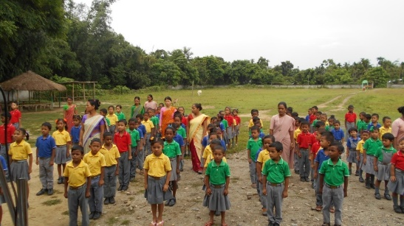Aims of the “Holy Cross School” Bokola:

• to make it possible for this area to become as literate as possible.

• to established a hostel for girls to secure sustainability of their education

• a wall around the area to protect and demarcate the school.

• to strengthen the trust, the self-confidence and the ambition of the people for a better life.

**2. *St. Augustin University in Mbeya, Tansania (SAUT), Africa*:**

**Extension and renovation of the Auditorium in St. Augustin University, Mbeya Center, Tanzania**

**Aims**:

• more students for the lectures

• more students to take part in special seminars

• to offer the room, wherever needed, as a study hall

• to guarantee an environment conducive to learning

• to make higher studies possible for more students.

**Reasons for the need of the project**:

The diocese gave SAUT the buildings of a former center for vocational training to offer programs to obtain certificates, diplomas and BA-courses for persons of Tanzania.

Now, the «SAUT-Mbeya Centre» is in urgent need to renovate and extend the auditorium to accommodate 350 students (at present there is room for 120).

Due to lack of space, a shift-lecture-operation had been introduced. Consequently, the activities in the University are going on till 10 p.m. This is unacceptable for lecturers and students alike, also for reasons of lack of transport facilities for the way home. There are students who live at large distances from the University.

Moreover, the present auditorium is not equipped adequately to meet the needs: Electronic equipment is needed, projectors, large screens, loudspeakers, amplifiers etc.

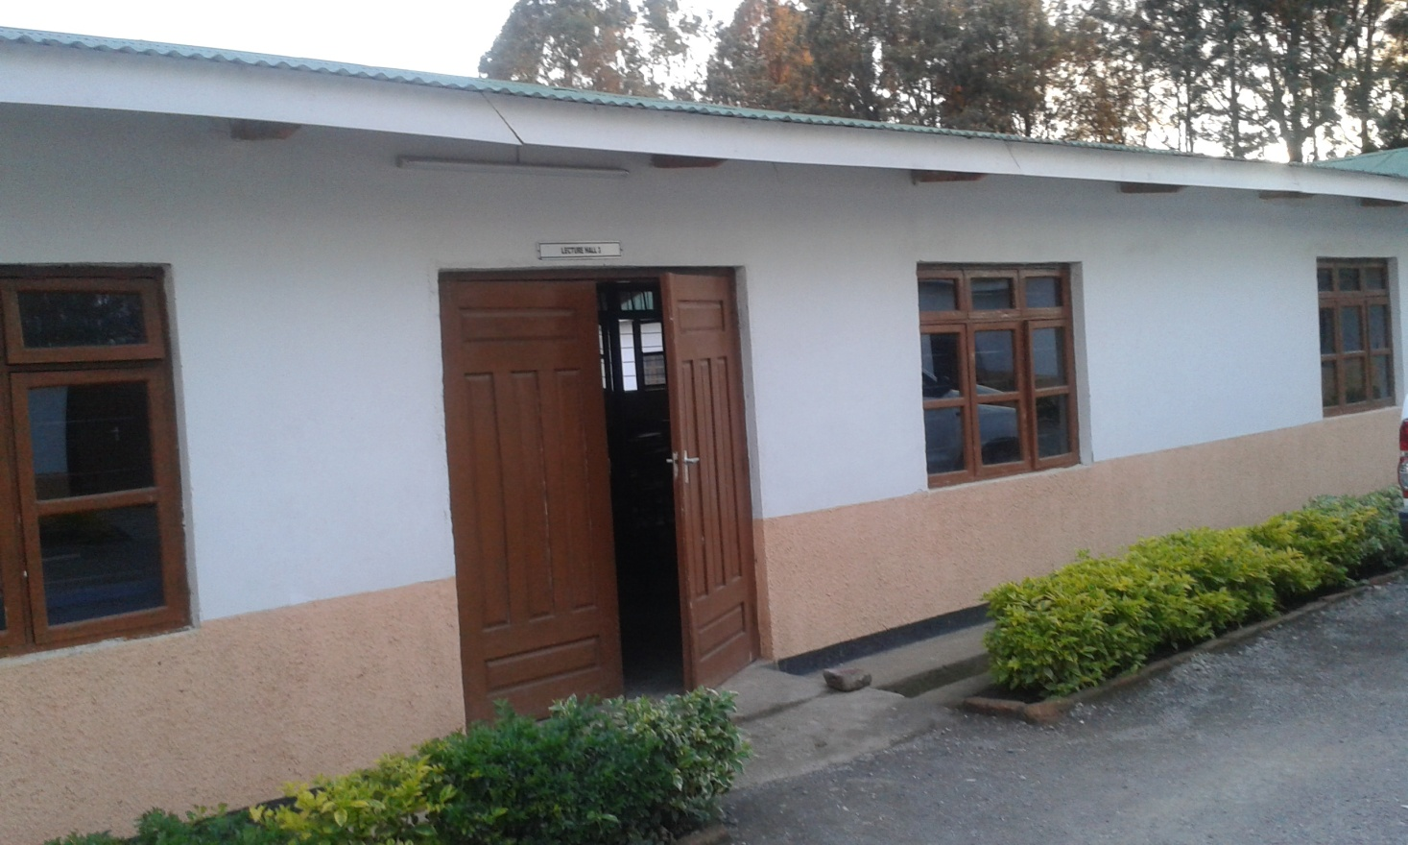 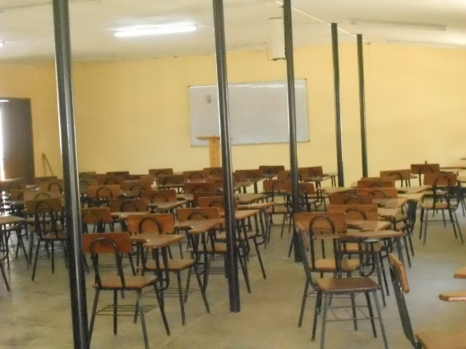

**3. Caritas Switzerland, Lucerne; Food Aid for 50 000 persons in Aleppo**

With the battle around Aleppo, the Syrian conflict assumes a new dimension of horror. Tens of thousands of persons are fleeing in the direction of the Turkish border; the humanitarian emergency in the city of Aleppo itself is heating up. Caritas Switzerland contributes to a project securing sustenance of 45 000 local displaced persons; in addition, it continues the soup kitchen in Aleppo, where 6300 persons receive a warm meal every day.

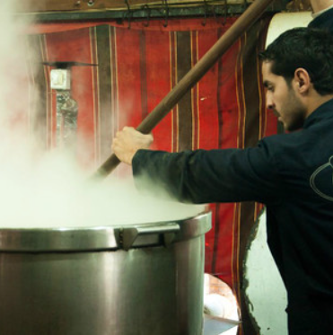

Despite violent bombing raids and street battles, several crores of persons are still persevering the city of Aleppo. The escape routes keep getting ever more dangerous and the sustenance ever more precarious. Since the past year, Caritas Switzerland, together with local church-based partners, has organized a soup kitchen to serve hot meals to 6300 persons on five days a week. The meals include basic foodstuffs such as rice, bulgur, spaghetti, beans and lentils, being fortified, as far as possible, with milk products, fresh vegetables meat and spices. The soup kitchen, continues to exist, in spite of the deteriorating situation; the working team involved continues their service against the most dangerous risks.

***4. Holy Cross Institute Hazaribag, India Central: construction of the school in Ranchi***

Since 1967, the Holy Cross Sisters of the Province India Central have been running a. Montessori School in Ranchi, Jharkhand. After the pre-school time of three years, a different school had to be found for these children. This caused a difficult situation for the parents of these children.

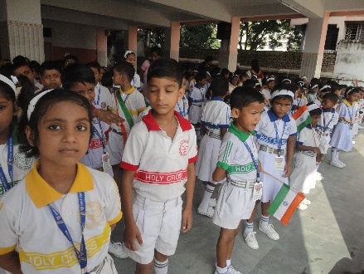

For years, already, these parents had asked for the extension of the school up to class twelve. Besides, the number of children suffering from physical and other handicaps, such as autism, is increasing. Such children are turned away by many other schools, along with children of the underprivileged sections of the population.

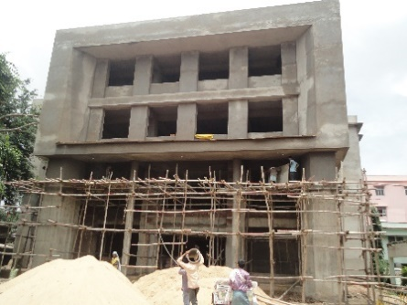In the year 2012, an English Medium School was opened in the rooms of the existing Montessori School in Burdwan Compound, Ranchi under the motto «The Need of the Time is the Will of God». The classrooms were improvised.

At the same time, the construction of a school building in the areal belonging to our society was started. This province is not able to take up the financial guarantee from its own resources.

Meanwhile, more than 460 students are attending the Montessori classes. Until the completion of the new building, an additional 575 students of the »English Medium School» - a total of 1035 students, will have to share the facilities of the Montessori School.

The new building is about to be completed; this means that the students are getting the possibility to continue in this school up to class 12. This is of great importance to the parents who are greatly nterested

in the education of their children.

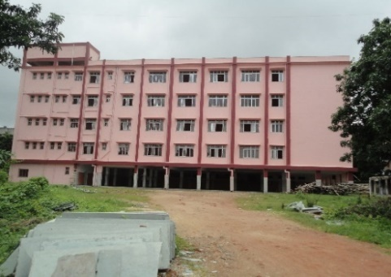

The aims of this school under the motto «The Need of the Time is God’s Will»:

• make the students aware of the present situation in the State

• motivate them to work for peace, harmony and brotherhood and to see and fight the discrepancy between rich and poor.

• offer the students an education based on basic values as well as on action and reflection

• promote the allround development of the students.

Knowledge of English is an essential condition for good jobs and higher studies. Therefore, the establishment of an «English Medium School» was an essential need for the people of this area. Most people are looking for a Christian mission school for their studies (and that of their children).

***5. Little Sisters of St. Francis of Assisi, Nkokonjeru, Uganda:***

Purchase of four water tanks in the boarding section of the primary school Stella Maris in Nsuube.

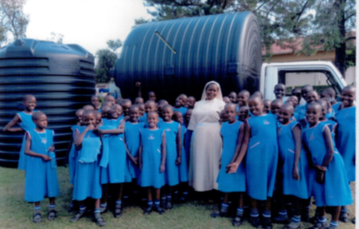

The school has no reliable access to water since it is situated at a large distance from the source of water.

This school has 605 girl students, 29 lady teachers and 40 assistants.

Due to the lack of a big water tank to collect the rain water, the boarding section of the primary school Stella Maris, the population of the nearby settlement as well as the farm of the school have big water problems.

Fetching water is dangerous for the girls. We find it difficult to take the responsibility for girls between the age of 6 and 14 years to be sent alone through the dense forests for this purpose. Things have happened in this line - also with wild beasts.

As a prevention against various sicknesses, the observation of basic hygienic measures is and urgent necessity. The great lack of sanitary facilities is considerable and has its effect particularly in the dry season.

The installment of water pumps is too expensive.

The collection of rain water and enough water tanks also contribute to the stabilization of the school

campus

. 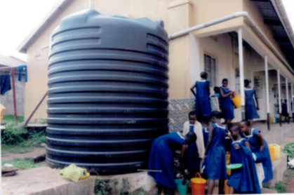

***6. Villages Unis, Geneve: Project for public health (drinking water, sanitary equipment and hygiene) in Malawi***

This project includes 3 subject areas 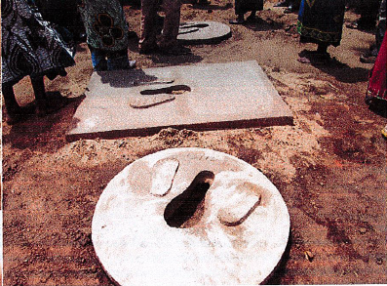

1. Support of several communes to establish a health-infrastructure: Setting up of 500 water places and 500 latrines, in collaboration with the people of the village.

2. Implementing of responsibilities for services, inclusively the storing of spare parts.

Repair of pumps,

Taking care of and responsibility for the water places in the districts.

3. Awareness raising for the local population on hygiene and sanitary practice as a condition for the use of the equipment.

The project makes possible the access to clean water, to sanitary equipment and hygiene, especially for children, women and elderly persons.

The responsibility will be taken up by the local population.

***7. Baselios Cardinal Cleemis, Major Archbishops House, Trivandrum, Kerala, Indien South: Setup of the kindergarten school in Kalathara, Kerala***

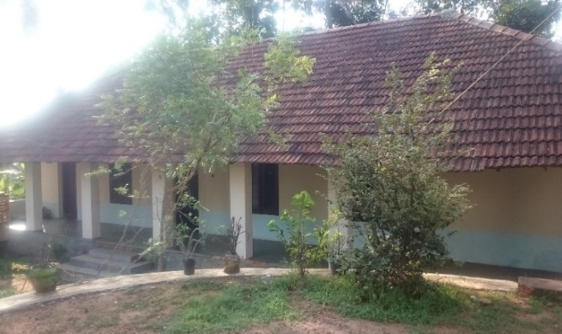 

The village of Kalathara is situated 22 kilometers from Trivandrum. At present, there are 25‘000 Christian and non-Christian families in this place. About 55 per Cent of the population work as bricklayers or day laborers. A great number of the villagers (elderly persons), due to their lacking possibilities for education in this village and their difficult financial situation have discontinued their schooling prematurely. Today, they are ever more aware of the necessity of professional training, trying their best to make a better schooling possible for their children. In the neighboring city Trivandrum, there are many very good schools. However, largely due to their difficult financial situation, the people of this village do not have access to them.

Therefore, in the year 2005, the primary school grew into a middle school, and then, these last years, extended further still. . Meanwhile, there are ten classes (Standards one to ten) with a total of 3000 girl-and boy-students. Within a relatively short time, the school got the recognition of the local public and the population of the neighboring villages. In the year 2015, in a small adjacent building, a small kindergarten (lower and upper kindergarten) was opened. Therefore, three additional classrooms and a teachers’room would be urgently needed.

***8. Brazil: Mosteiro do Salvador, Brazil: Building of a protection wall to safeguard the convent on the border of a Favela***

The convent of the Oblate Sisters is situated in Coutos, a neigboring city of Paripe. 

For several years, these Sisters have run an important social service for education and vocational training.

The present Abbess, Sr. Vera Lúcia, as a former ballet-dancer, had, moreover, established a ballet-dancers’school for children of the environment. Ballett-dancing has proved to have a positive effect on the self-esteem of many poor girls, promoting also all the other intellectual and vocational achievements.

For their own maintenance, the Sisters prepare hosts, produce paraments and other handiworks, depicture cards to generate some income by selling them.

Due to the increasing threatening, it is needed to protect the convent and premises with a retaining wall. Burglaries and thefts are on the increase. The existing wire fence can easily be overcome. The Sisters, as well as the girl students, are being harassed and threatened.



A Favela has come up around the convent; consequently, the drug problem has become acute.

***9. Sisters of Mercy of the Holy Cross, Kosovo Region: Financial Support for Poor Girl Students in the Academic Year 2016/17***

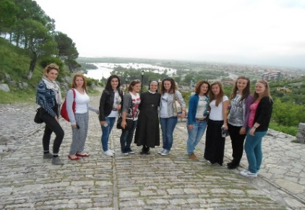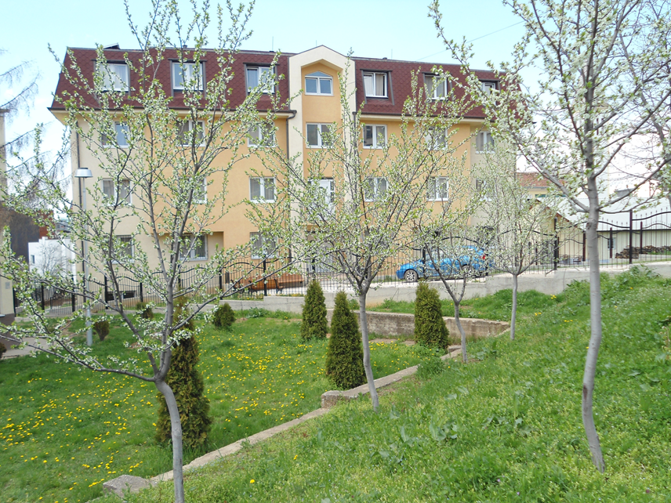

At present, there are 80 women-students with different religious orientations studying in various Universities in the town.

Many of them come from poor families and are hardly able to meet the financial cost for board and lodging.

Thanks to our financial support, it became possible this year for ten women students to be completely freed from the cost for board and lodging, and 25 women students had to pay just part of it.

The Foundation works targeted and transparently, demanding the respective account on the amounts given by the donors.

In conclusion of our report, we would like to express our joy on the fact that, thanks to the financial support by means of our Foundation, it is possible for us to relieve distress and give hope.

A sincere thank you to all who support our Foundation with their donation and to make our help possible. Thank you for your loyalty over many years.

Brunnen, 31.3.2017

President of the Foundation Member of the Foundation Council

Sr. Marija Brizar Sr. Jaroslava Katulakovaj