[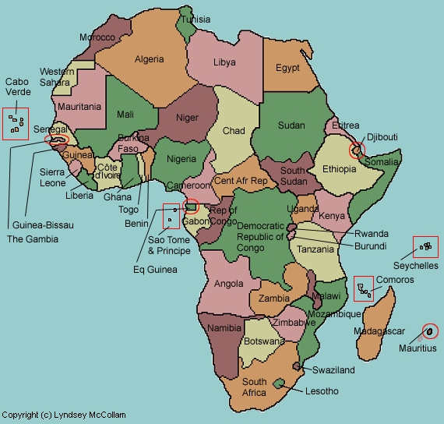](https://www.google.ch/url?sa=i&rct=j&q=&esrc=s&source=images&cd=&cad=rja&uact=8&ved=0ahUKEwitwpiXvcDYAhWMK1AKHVO7ByEQjRwIBw&url=https://lizardpoint.com/geography/africa-quiz.php&psig=AOvVaw0WodsYDxPf4-qxZ3PJoL7A&ust=1515229810707098)

**Uganda**

1. Namugongo

(**Vicariate House**)

1. Kiziba
2. Busunju
3. Kikyusa
4. Osia
5. Kamwenge -(**Mahyoro**)

**Kenya**

1. Bulimbo

**Map of Africa**

[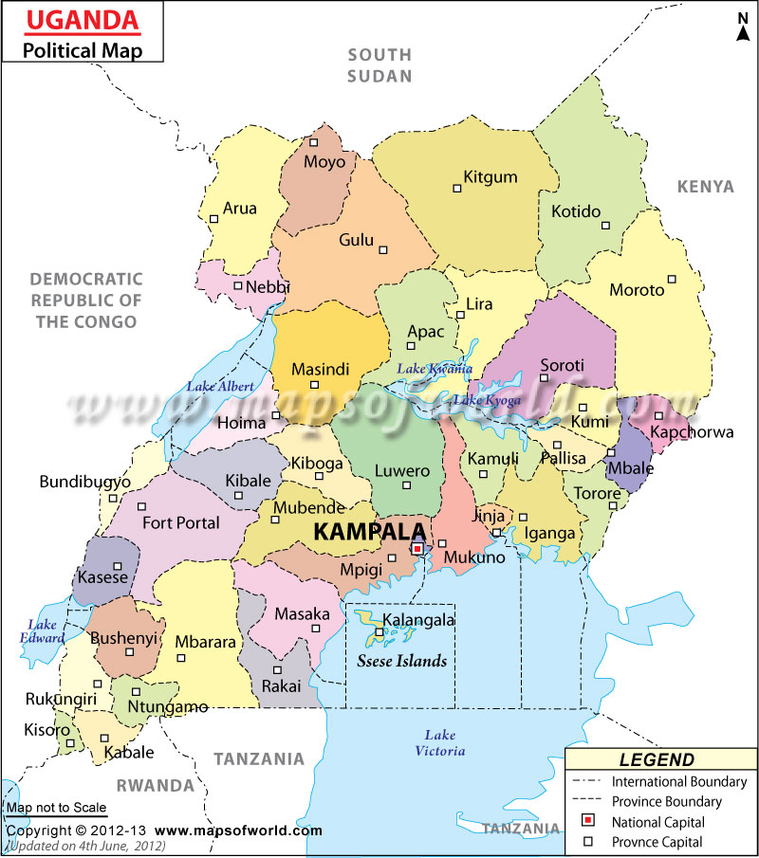](https://www.google.ch/url?sa=i&rct=j&q=&esrc=s&source=images&cd=&cad=rja&uact=8&ved=0ahUKEwiC18D5z7vYAhWJLlAKHRHtBjAQjRwIBw&url=https://www.pinterest.com/pin/476466835546729946/&psig=AOvVaw0EHcfqgfT2W8ixX2KCyaOl&ust=1515063029393017)

**6**

**4**

**3**

**2**

**7 K.**

**5**

**1**

KENYA